Manolis Κiagias, MSc

FreeBSD 12.1-RELEASE


Base System to Desktop Environment

Chania, 2019

(C) 2019 Manolis Kiagias, sonic2000gr@gmail.com
This Work is provided under the terms of the License:

Attribution-NonCommercial-ShareAlike 4.0 International
The complete text of this license is available here:
http://creativecommons.org/licenses/by-nc-sa/4.0/

You are free to:
Share – copy and redistribute the material in any medium or format
Adapt – remix, transform, and build upon the material
The licensor cannot revoke these freedoms as long as you follow the license terms
Under the following terms:
 | Attribution — You must give appropriate credit provide a link to license, and indicate if changes were made. You may do so in any reasonable manner, but not in any way that suggests the licensor endorses you or your use
 | NonCommercial – You may not use the material for commercial purposes.

 | ShareAlike – If you remix, transform, or build upon the material, you must distribute your contributions under the same license as the original.  No additional restrictions – You may not apply legal terms or technological measures that legally restrict others from doing anything the license permits.
Notices:

You do not have to comply with the license for elements of the material in the public domain or where your use is permitted by an applicable exception or limitation. No warranties are given. The license may not give you all the permissions necessary for your intended use. For example, other rights such as publicity, privacy, or moral rights may limit how you use the material.

Η Εγκατάσταση του FreeBSD 12.1-RELEASE 5
Αναβάθμιση του Base System 16
Εγκατάσταση του Εργαλείου Διαχείρισης Πακέτων 16
Εγκατάσταση Βασικών Προγραμμάτων Κονσόλας 17
Ρύθμιση του Sudo 18
Αλλαγή Shell στον Απλό Χρήστη 18
Εγκατάσταση και Ρύθμιση Γραφικού Περιβάλλοντος 19
Εγκατάσταση Xorg Server 19
Εγκατάσταση Desktop Environment 20
Απευθείας Εκκίνηση σε Γραφικό Περιβάλλον 21
Τερματισμός από το Γραφικό Περιβάλλον 22
Εναλλαγή Ελληνικού / Αγγλικού Πληκτρολογίου 22
Εναλλαγή Πληκτρολογίου μέσω Γραφικού Εργαλείου 22
Εναλλαγή Πληκτρολογίου μέσω Xorg 23
Εναλλαγή Πληκτρολογίου μέσω Script 23
Εγκατάσταση Browsers, Media Players κ.α. 24
Ενημέρωση των Εγκατεστημένων Εφαρμογών 24

For comments / corrections: sonic2000gr@gmail.com

Installing FreeBSD 12.1-RELEASE

Before beginning the installation of an operating system, the BIOS has to be adjusted to boot from the intended installation media. Most of the newer PC hardware have the ability to boot off USB devices such as flash drives as well as from CD/DVD drives.

FreeBSD comes in different versions for 32 and 64bit PC architectures as well as many others. Typically, the 32bit version is intended for systems utilising an older processor (or smaller amounts of RAM, generally less than 4GB) and the 64bit version for more modern processors and capable systems.

While FreeBSD is available both on CD and DVD, the DVD version is not required for this install. The DVD contains ready-made packages that are also available online. For this install we are using the 32bit disc1 ISO image and VirtualBox. If you wish, you may download the complete Appliance of this install here:

http://www.schoolspace.gr/files/FreeBSD-12.1-RELEASE.zip

The password for both user and root accounts is 1234

Booting off the installation media, after a while the following dialog appears:

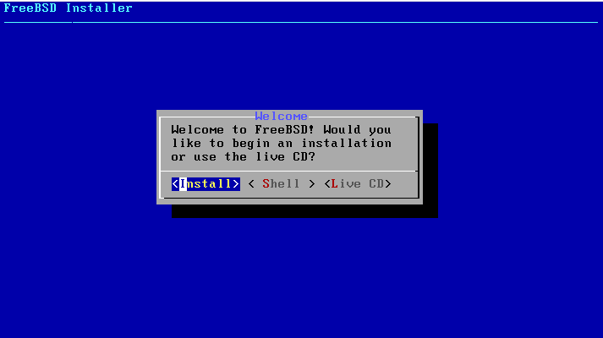

Just press Enter on the default Install option.

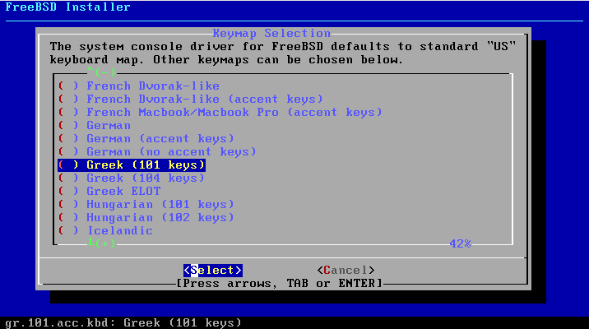

Select the desired keyboard layout. This is not a critical setting for a desktop system as it will not affect your GUI settings. If a layout does not seem to match your keyboard/language, just select the US layout.

During the installation process, use the arrow keys to move between options. Use the SPACE bar to mark any checkboxes. Move between different dialog parts (such as the main dialog and the OK / Cancel buttons) using the TAB button.

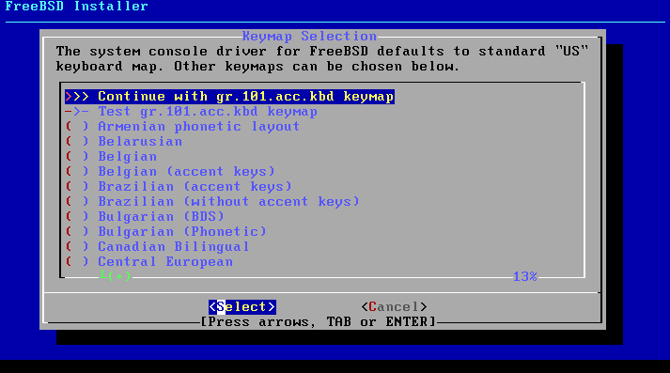

After selecting the keyboard layout, use the arrow keys to select “Continue wth <your selection” and press ENTER on this dialog to confirm it.

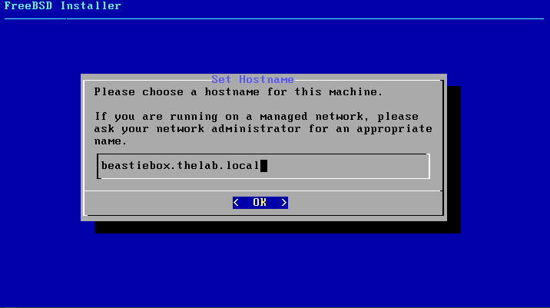

Every system must have a hostname. Typically, a system also belongs to a domain. As our sample system is not directly connected to the Internet (it is most probably served by a home DSL router) any domain name may be chosen. As an example, the domain name is thelab.local and the hostname is beastiebox. Original hostnames for a system are many times based on plants, planets, constellations and animals. Something as dull as system01 may also be used!

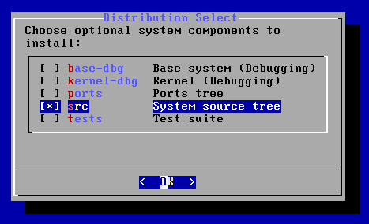

Select the additional or optional components to install. There is no need to select the Ports tree as the version on the CD is outdated and the ports can be readily installed off the Internet. The system source code is useful as a reference and if you plan to build your own kernel. A few programs from the Ports Collection may also need the system source code in order to build.
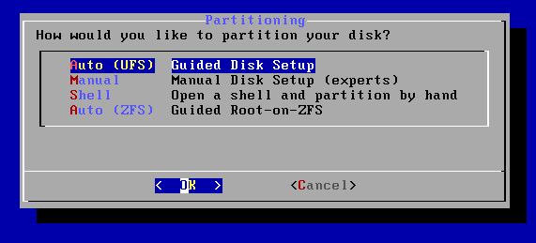

There are many different ways to partition the system’s disk. The easiest method is to use the default Guided option. FreeBSD can be installed on the traditional UFS filesystem or the newer ZFS. For an older system using the 32 bit installation media, the best option would be UFS. ZFS is recommended for modern systems with adequate amounts of RAM (4GB or more). For this install in VirtualBox we selected UFS for simplicity.

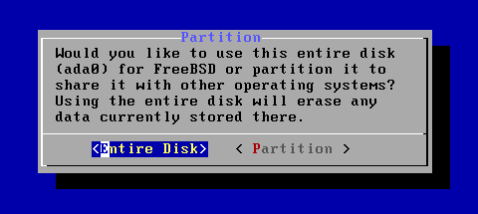

Assuming a completely empty disk, select the Entire Disk option. Note that this will erase anything on the disk and create appropriate BSD partitions! Multi boot systems may be created using the Partition option, however this is outside the scope of this concise guide.

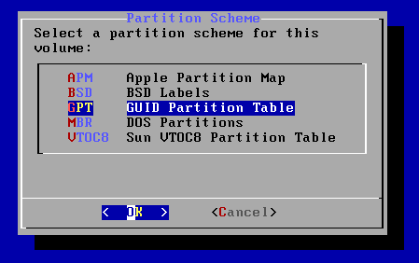

The newer partitioning scheme is GPT and allows more than four primary partitions on a disk. Most system have no trouble booting from GPT partitions, so this option is recommended. The older MBR style partitions may also be used.

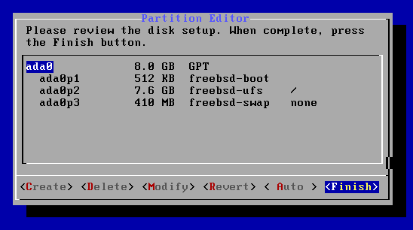

Depending on the disk and RAM size of your system, the installation program will suggest different partition sizes. The default settings may usually be accepted. Using the options in this dialog the sizes may be customized or additional partitions may be created. Sometimes it is useful to shrink the size of the root partition (marked as “/”) and create a separate partition for /home. For this sample installation, simply select Finish.

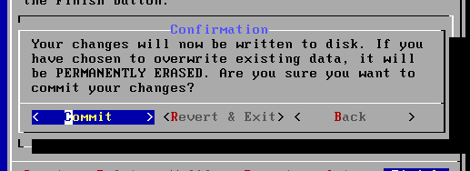

This is the final warning: After selecting Commit, changes will be written to disk, partitions will be created and formatted and files will be copied. Any existing data on the disk will be lost after pressing Commit.
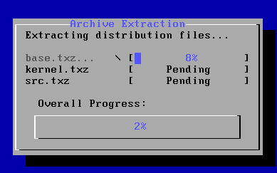

File copying will take a while.

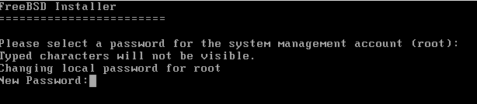

Set the password for root (admin) user. Use a safe, long password that may not be guessed. Your birthday, phone number and 1234 are all unsafe passwords!

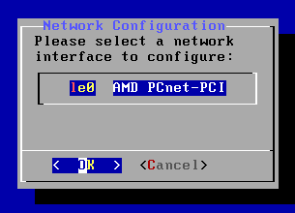

The above dialog will appear if the installation program detects a network card. If more than one network cards are detected, their models will be listed here allowing to choose which one to configure. If your system is equipped with a WiFi adapter that is recognized by FreeBSD, you will also be presented with a number of dialogs allowing you to connect to your home network and type the appropriate password, if applicable.

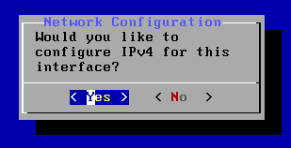

The answer here is obviously yes.

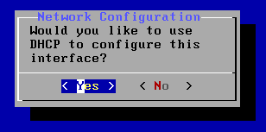

If Yes is selected, the network card will be autoconfigured by a DHCP server on your network (most probably your home router). Otherwise, a number of dialogs will be shown, allowing the settings to be made manually.

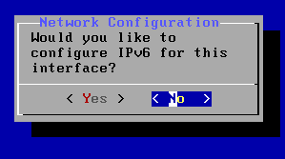

If IPv6 is available select Yes. Otherwise select No.

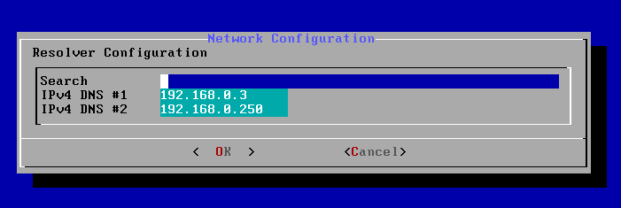

Having selected DHCP for the network settings, this dialog will show some of the settings obtained by the DHCP server. These are the DNS servers that will be used (will be automatically written to the generated /etc/resolv.conf file).

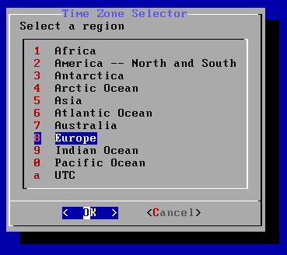

Select your region and country / time zone.

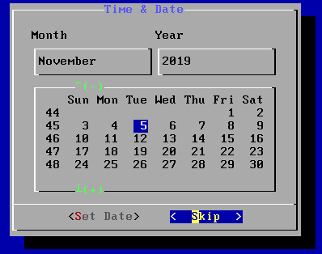

The above dialog allows you to confirm / set the correct date for your system. It is followed by a similar dialog allowing you to set the time. Please confirm the settings are correct. Usually FreeBSD assumes the system BIOS uses UTC time.

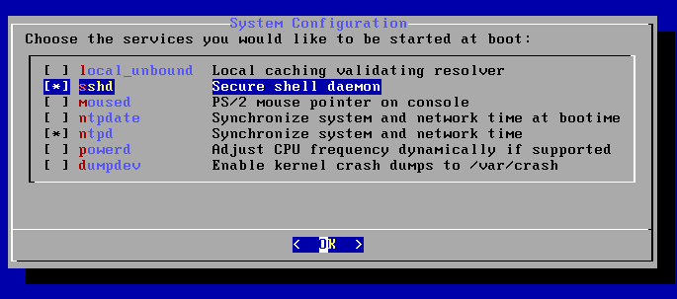

Select the services (or daemons) to run at startup:

- For remote shell access, select sshd
- For mouse operation on the console, select moused
- For automatic, Internet based clock synchronization, select ntpd. This option is usually enabled.
- For CPUs with power saving features, you may wish to select powerd.
- dumpdev is probably not useful for typical desktop use.

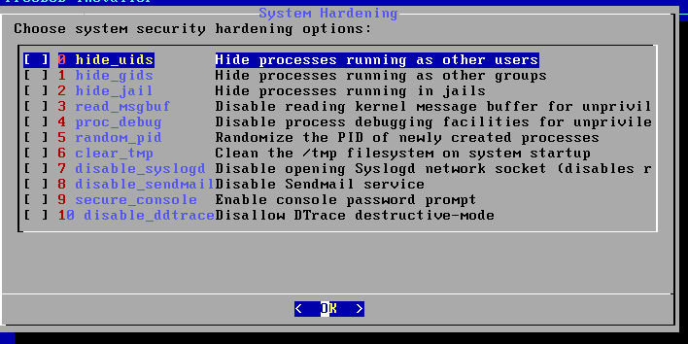

This dialog allows selection of system hardening options. We will be leaving these blank for now, as explaining them is beyond the scope of this guide. You are advised to study the relevant sections in the FreeBSD Handbook to decide whether to use any of these options. Note that all these options may be changed at any time after the initial install of the system.

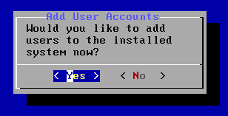

Add users to the system. It is advisable to add at least one standard use now or immediately after the installation is finished.

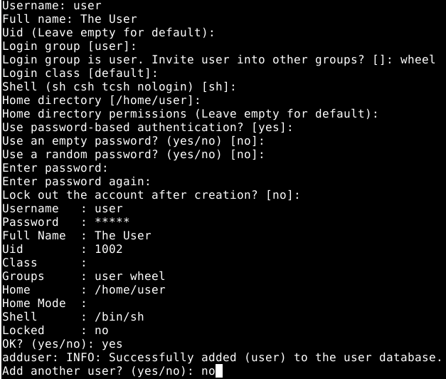

Like hostnames, usernames are entirely up to choice. The example shows a rather simplistic user username. It is good practice to make at least one of the user account a member of the wheel group. Members of wheel can use the su command to become root when needed (without having to logout/login). For the rest of the users, the default options may be used.
You may add users after the initial installation using the adduser command as root. This is the same command actually used in the installer above.

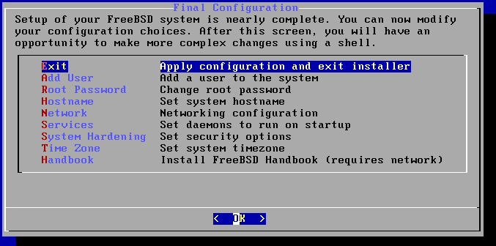

We’re at the end of the installation, and we may choose Exit.

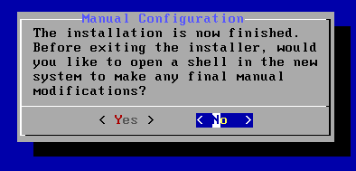

No more changes are needed, select No.

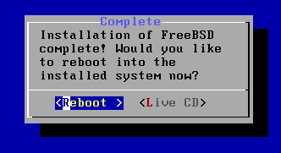

Finally, select Reboot to start your new system. Remember to remove the installation media before restarting!

At the end of the first startup, at the Login: prompt, enter root and the use the password you typed earlier in the installation program.

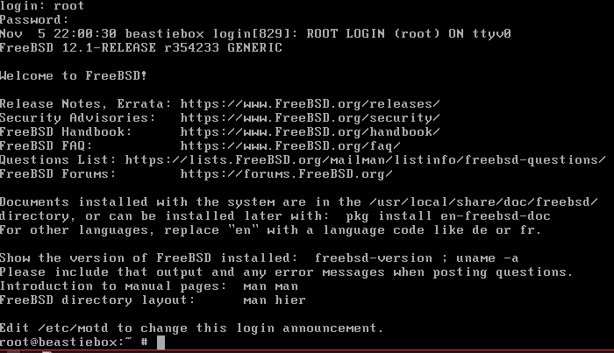

We are now ready to start updating our new system and install application programs.

Update the Base System
Note: The “#” has symbol means the next command must be run by the root user. The “$” sign means the next command must be run by a standard user. These symbols should not be typed as part of the commands!
Before any application programs are installed, it is good practice to update the base system with the latest security and bug fixes:
# freebsd-update fetch install
Looking up update.FreeBSD.org mirrors... 5 mirrors found.
Fetching public key from update4.freebsd.org... done.
Fetching metadata signature for 12.1-RELEASE from update4.freebsd.org... done.
Fetching metadata index... done.
Fetching 2 metadata files... done.
Inspecting system... done.
Preparing to download files...
The following files will be updated as part of updating to 12.1-RELEASE-p1:
/bin/freebsd-version
/boot/kernel/kernel
...
Installing updates... done.
Many security updates contain fixes to the kernel and require the system to be rebooted after the installation:
# shutdown -r now
After rebooting, login again as root.

Installing the pkg Command, the Interface to Package Management
In recent FreeBSD versions, the default package management system was switched to a new version called pkgng. The system allows easy installation of ready made packages that are available in the FreeBSD Project servers, without the need for time-consuming source builds. Ready-made packages are ideal for desktop systems where a lot of complex and large programs are needed for a functional GUI. The traditional Ports Collection method is also still available and may be used when special build options are required or where packages are not available (for example due to licensing issues).
To begin working with packages, the pkg command must first be initialized. As root, simply type:
# pkg
The package management tool is not yet installed on your system.
Do you want to fetch and install it now? [y/N]: y
Bootstrapping pkg from pkg+http://pkg.FreeBSD.org/FreeBSD:12:i386/quarterly, please wait...
Verifying signature with trusted certificate pkg.freebsd.org.2013102301... done
Installing pkg-1.12.0...
Extracting pkg-1.12.0: 100%
The program will be downloaded and installed automatically. Update the database of available packages:
# pkg update
Updating FreeBSD repository catalogue...
Fetching meta.txz: 100% 944 B 0.9kB/s 00:01
Fetching packagesite.txz: 100% 6 MiB 504.5kB/s 00:13
Processing entries: 100%
FreeBSD repository update completed. 32397 packages processed.
All repositories are up to date.

We are now ready to install some basic text-mode tools.

Installing Basic Command Line Tools
Some basic tools for the command line are:
bash | The Bash shell is very common in the Linux world and you may wish to use it as a shell for many standard users (not for root!)
screen | Screen is a useful utility when a session needs to be left active with the user logging and reconnecting to it from a different terminal.
zip, unzip  unrar | These utilities allow handling of compressed archives.
sudo | A utility to run commands as root from a user account.

To install all of the above, simply type:
# pkg install bash screen sudo zip unzip unrar
Updating FreeBSD repository catalogue...
FreeBSD repository is up to date.
All repositories are up to date.
Updating database digests format: 100%
The following 8 package(s) will be affected (of 0 checked):
...

Setting Up Sudo
To allow a user to issue commands as root, an initial setup of the sudo command has to be performed using the visudo utility. When visudo is executed, an editor is opened (typical vi) with the sudo configuration file already loaded. To temporarily set another, easier, editor for visudo, change the EDITOR environment variable:
# setenv EDITOR ee
Execute the visudo command:
# visudo
Remove the comment symbol (#) from the wheel line:
# %wheel = ALL (ALL) ALL
so it becomes:
%wheel = ALL (ALL) ALL
This change will allow everyone in the wheel group to issue commands as root. If this is not desirable, individual usernames may be added like this:
nikos = ALL (ALL) ALL
Αποθηκεύουμε (πιέζουμε ESC, Leave Editor και Save στο μενού).
Save the file (if using ee, press ESCAPE, Leave Editor and Save). Sudo allows more complex configurations where a user may have limited root abilities, however this is beyond the scope of our setup.
To test sudo functionality, logout out from the root account and login again as the standard user created during setup (which should belong to the wheel group). Issue a simple (harmless) command:
$ sudo ls
The system will ask the user password and execute the command.

Configuring the Bash Shell for the Standard User
We may change the shell for our standard user to the more common “bash” shell we previously installed. Bash is the default shell in most Linux distributions and is enhanced compare to the standard /bin/sh.
We never change the shell to the root account! Root’s shell is /bin/csh.
Logout of root, login as user, and type:
$ chsh -s bash
You will need to enter your password to confirm the change.
Bash has two primary configuration files: .profile and .bashrc
In Unix, all files beginning with a dot (dotfiles) are hidden. The .profile file already exists and needs a few simple changes, but .bashrc must be created from scratch. For convenience, you may download and install our versions as follows:
$ cd ~
$ fetch http://www.schoolspace.gr/files/dotfiles-us.zip
Unzip the files:
$ unzip -o dotfiles.zip
Logout and login as standard user to see the difference.
The .profile file is loaded every time the user logs in. The .bashrc file is loaded when a non-login shell is started. A non-login shell is started when the user starts bash manually or by opening a graphic terminal in a GUI environment. Both files contain settings for the shell and the user’s environment. It is convenient to put most settings in .bashrc and have this file loaded in both login and non-login shells. For this purpose, the following lines have been added to the end of .profile:
if [ -f ~/.bashrc ]; then
source ~/.bashrc
fi
In .bashrc, lines like::
export LANG=en_US.UTF-8
set environment variables for the user. The shell remembers these settings and makes them available to programs that request their values. For example, the line above sets the system language for the user to US English, while the line below sets the default editor to ee:
export EDITOR=ee
When a program requests an editor to open a file, the easy editor (ee) will be used. There are also alias lines like the following:
alias ls='ls -G'
When the user executes the ls command, ls -G will be the one actually executed. The -G parameter in ls is used to enable colour coded files and directories in the output. Finally the line:
PS1=...
changes the prompt of the shell and is responsible for the blue colour and the extra info appearing in front of the “$” sign.
Have a look at the rest of the lines by opening the file using ee:
$ ee ~/.bashrc

Installing and Setting Up a Graphic Environment
Installation of a GUI consists of the following steps:
- Installing Xorg Server
- Installing the desired Desktop Environment (DE) or Window Manager (WM)
- Setting up and testing the installation
- Optionally installing a keyboard layout switching solution (if the user needs to switch between two or more languages / layouts)
- Optionally installing a login manager so the system starts by default to a GUI.
- Installing additional programs for media playback, web browsing, document creation etc.

Installing Xorg Server
This is very simple. As root:
# pkg install xorg
For a VirtualBox installation, install the additions as well:
# pkg install virtualbox-ose-additions
Install some extra fonts:
# pkg install liberation-fonts-ttf urwfonts-ttf freefont-ttf webfonts
Edit the file /etc/rc.conf and add this line:
dbus_enable=”YES”
The rc.conf file is one of the most important FreeBSD configuration files. It contains the network, hostname and console settings. It also contains lines describing the services (or daemons) to be started at system startup as well as some of their optional parameters. For every service that starts when the system is booted, there is a line like the following:
<servicename>_enable=”YES”
The order of appearance of these lines in rc.conf is not important. The FreeBSD startup system will always start system services in the correct order (for example, taking care to start services that need the network after the network connection is established)
If you followed our installation instructions this far, your user account is already a member of the wheel group. If not, type the following command:
# pw groupmod wheel –m user
You may also add the user account to the video group. The user must be on one of these group (wheel or video) for Xorg to work correctly:
# pw groupmod video –m user
(use the account name you created if different from ‘user’)
For VirtualBox only:
For virtualbox installations, add these lines to /etc/rc.conf:
vboxguest_enable=”YES”
vboxservice_enable=”YES”
vboxservice_flags="--disable-timesync"
Normally, Xorg configures itself automatically to work with the graphics card / monitor it detects. There is usually no need to create an xorg.conf file like the older versions. You may however need to install the graphics card drivers package depending on your hardware:
- For VirtualBox the driver is included in the package virtualbox-ose-additions we already installed
- For common Intel graphics cards (included in most laptops and many desktop systems with onboard graphics) install drm-kmod:
# pkg install drm-kmod
- For Nvidia based cards there are drivers available directly from Nvidia. To install the latest driver:
# pkg install nvidia-driver
- For AMD based cards, install drm-kmod:
# pkg install drm-kmod
You may find more information in the FreeBSD Handbook and the FreeBSD Wiki:
https://www.freebsd.org/doc/handbook/x-config.html
https://wiki.freebsd.org/Graphics

Installing the Desktop Environment
FreeBSD does not come with a default GUI but many are available as packages and in the Ports Collection. A simple, non resource intensive GUI with a familiar look and feel is XFCE. Installation is very easy:
# pkg install xfce
Logout and login as a standard user. Use ee to create the .xinitrc file:

$ cd ~
$ ee .xinitrc
Content:
export LANG=en_US.UTF-8
exec startxfce4
Restart the system to load all relevant drivers and daemon we previously installed:
# shutdown –r now
The login as standard user and execute:
$ startx
The default XFCE desktop will soon appear:
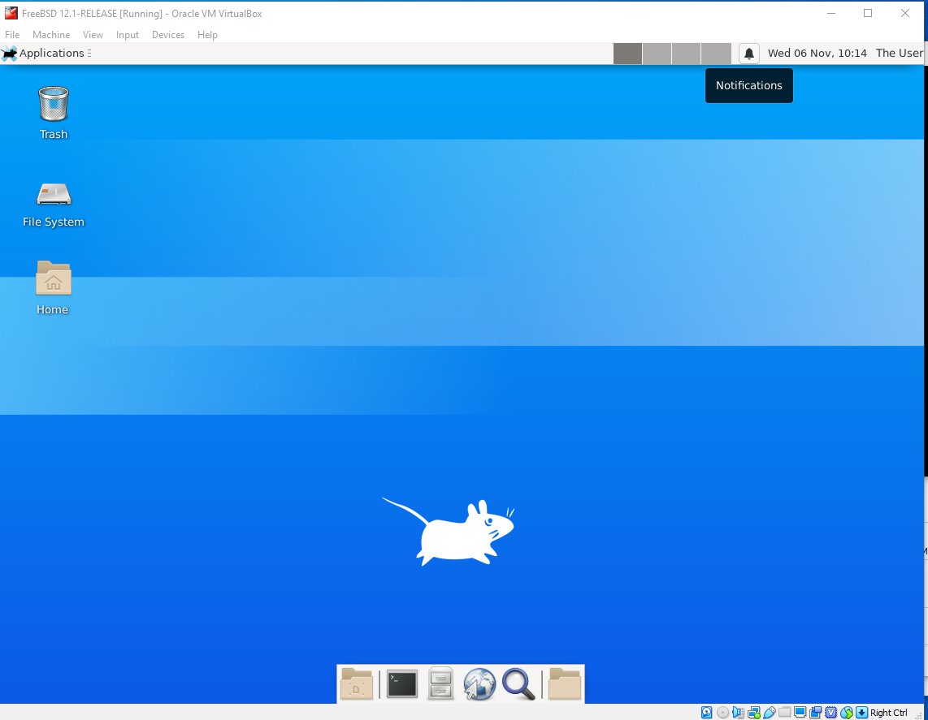

We never execute a GUI as root!

Απευθείας Εκκίνηση σε Γραφικό Περιβάλλον
Είναι αρκετά πιθανό να θέλετε το σύστημα σας να εκκινεί απευθείας σε γραφικό περιβάλλον αντί για την κονσόλα. Αυτό είναι το τυπικό στα περισσότερα desktop συστήματα. Η απευθείας εκκίνηση / login σε γραφικό περιβάλλον ρυθμίζεται διαφορετικά ανάλογα με το γραφικό περιβάλλον που εγκαταστήσαμε. Το XFCE δεν διαθέτει δικό του login manager, μπορούμε όμως να χρησιμοποιήσουμε κάποιον άλλο όπως το GDM (GNOME) ή το XDM. Στην δική μας εγκατάσταση προτιμήσαμε ένα αρκετά απλό login manager που είναι το slim:
# pkg install slim
Προσθέστε την παρακάτω γραμμή στο /etc/rc.conf ώστε το slim να ξεκινά αυτόματα στην εκκίνηση:
slim_enable=”YES”
Μετά την επανεκκίνηση θα δείτε την παρακάτω οθόνη login:
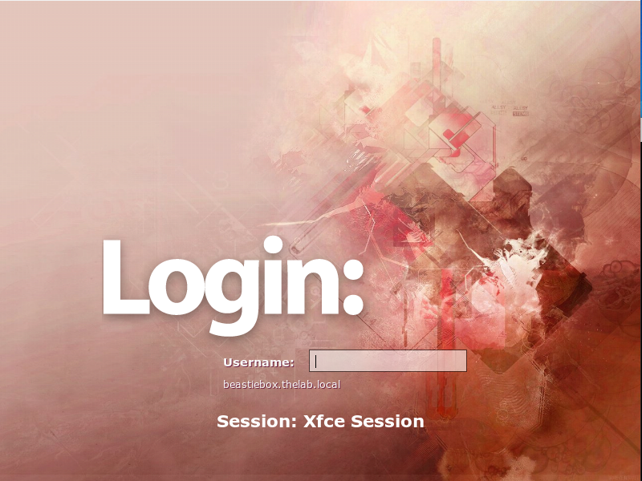

Τερματισμός από το Γραφικό Περιβάλλον
Αν και φυσικά μπορείτε πάντα να τερματίζετε το σύστημα σας από το τερματικό του γραφικού περιβάλλοντος (ή την κονσόλα), μετά τη γραφική εκκίνηση ίσως θέλετε να το κάνετε από το μενού του XFCE. Τη δεδομένη στιγμή οι επιλογές για shutdown / restart είναι ανενεργές δεδομένου ότι ένας απλός χρήστης δεν έχει φυσιολογικά τα δικαιώματα τερματισμού του συστήματος. Για να γίνει αυτό θα πρέπει να φτιάξουμε ενα αρχείο κανόνων για το policy kit.
$ su -
# cd /usr/local/etc/polkit-1/rules.d
# fetch http://www.schoolspace.gr/files/shutdown.rules
Μπορείτε να δείτε το περιεχόμενο του αρχείου για να καταλάβετε πως λειτουργεί. Για να βρείτε πως το ανακαλύψαμε, γράψτε:
# pkg info –D xfce4-session
Μετά την επανεκκίνηση θα δείτε ότι πλέον είναι διαθέσιμες οι επιλογές shutdown / restart.

Εναλλαγή Ελληνικού / Αγγλικού Πληκτρολογίου
Υπάρχουν διάφοροι τρόποι να πετύχουμε την εναλλαγή Ελληνικού / Αγγλικού πληκτρολογίου με τη γνωστή συντόμευση alt + shift (ή άλλη της επιλογής μας). Ανάλογα με το γραφικό περιβάλλον μπορεί να χρησιμοποιηθεί κάποιος από τους παρακάτω τρόπου:
- Χρήση γραφικού εργαλείου για προσθήκη διάταξης πληκτρολογίου και πλήκτρων εναλλαγής. Το XFCE διαθέτει εργαλείο αυτής της μορφής
- Χρήση ρυθμίσεων στο xorg.conf οι οποίες λειτουργούν ανεξάρτητα από το γραφικό περιβάλλον που θα χρησιμοποιήσουμε. Αυτό είναι χρήσιμο ειδικά για μικρότερα γραφικά περιβάλλοντα / window managers τα οποία δε διαθέτουν γραφικό εργαλείο.
- Χρήση ενός script που εκτελείται στην εκκίνηση (ή χειροκίνητα) από το τερματικό και δεν απαιτεί να αλλάξουμε ρυθμίσεις του xorg.
Θα δείξουμε εδώ και τους τρεις τρόπους

Εναλλαγή Πληκτρολογίου μέσω Γραφικού Εργαλείου
Στο μενού του XFCE:
Applications ➔ Settings ➔ Keyboard
Κάντε τις ρυθμίσεις που φαίνονται παρακάτω:
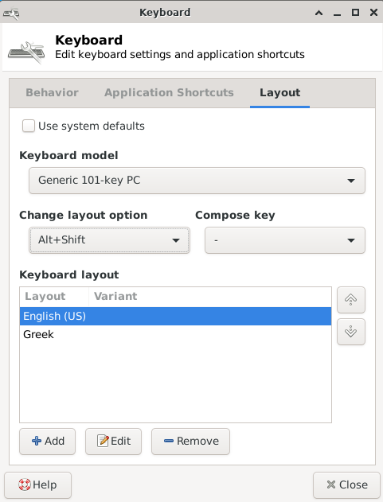
Οι αλλαγές θα ισχύσουν άμεσα μόλις πιέσετε «Close».

Εναλλαγή Πληκτρολογίου μέσω Xorg
Η εναλλαγή πληκτρολογίου μέσω ρυθμίσεων του Xorg αποτελεί τον «παραδοσιακό» θα έλεγε κανείς τρόπο εναλλαγής ο οποίος μπορεί να χρησιμοποιηθεί και σήμερα. Για την τρέχουσα έκδοση μπορείτε να κάνετε το παρακάτω:
$ su –
# cd /usr/local/etc/X11/xorg.conf.d
# fetch http://www.schoolspace.gr/files/kbd-layout-multi.conf
Μπορείτε να δείτε το περιεχόμενο του αρχείου με τη βοήθεια του ee για να κατανοήσετε πως λειτουργεί. Το αρχείο αυτό φορτώνεται αυτόματα κατά την εκκίνηση του Xorg. Η αλλαγή θα ενεργοποιηθεί στην επόμενη επανεκκίνηση ή logout / login.

Εναλλαγή Πληκτρολογίου μέσω Script
Ένας τελευταίος τρόπος είναι να εκτελέσουμε από το γραφικό μας τερματικό (ως απλός χρήστης) ένα script το οποίο ουσιαστικά κάνει τις ίδιες ρυθμίσεις με την προηγούμενη μέθοδο, αλλά προσωρινά. Μπορούμε φυσικά να το βάλουμε να εκτελείται αυτόματα κατά την εκκίνηση (η μέθοδος εξαρτάται από το γραφικό περιβάλλον που χρησιμοποιείται):
$ cd ~
$ mkdir bin
$ cd bin
$ fetch http://www.schoolspace.gr/files/setgrkeyb

Για να το εκτελέσουμε:
$ bin/setgrkeyb

Εγκατάσταση Browsers, Media Players κ.α.
Μπορούμε εύκολα να εγκαταστήσουμε γραφικά προγράμματα όπως browsers και media players. Τώρα που είμαστε πλέον στο γραφικό περιβάλλον, εκτελέστε την εφαρμογή τερματικού (Applications Menu ➔ Terminal Emulator) και αποκτήστε δικαιώματα root:
$ su -
# pkg install firefox mplayer vlc
(Μπορείτε επίσης αντί για su να χρησιμοποιήσετε την εντολή sudo σαν κανονικός χρήστης: sudo pkg install κλπ)
Αν έχετε σκοπό να δουλέψετε με έγγραφα, λογιστικά φύλλα ή παρουσιάσεις μια δημοφιλής εφαρμογή είναι το libreoffice:
# pkg install libreoffice

Ενημέρωση των Εγκατεστημένων Εφαρμογών
Σε τακτά διαστήματα εκτελούμε τις εντολές:
# pkg update
# pkg upgrade
ώστε να ενημερώνονται τα πακέτα του συστήματος μας στις τελευταίες εκδόσεις. Ενδεχομένως μετά από μια αναβάθμιση να εμφανιστούν μηνύματα με οδηγίες που πρέπει να εφαρμόσουμε. Τις οδηγίες αυτές μπορούμε επίσης να τις δούμε οποιαδήποτε στιγμή γράφοντας:
# pkg info –D <pkg_name>
Για να βρούμε πακέτα προς εγκατάσταση χρησιμοποιούμε την εντολή pkg search:
# pkg search όνομα_πακέτου
Για να κατανοήσετε καλύτερα το πως και το γιατί αυτού του οδηγού, πρέπει να διαβάσετε το FreeBSD Handbook:
https://www.freebsd.org/doc/handbook/index.html
Χρήσιμες πληροφορίες θα βρείτε επίσης στο FreeBSD Wiki:
https://wiki.freebsd.org/

